**Global Malnutrition Trends (1983 – 2019)**

**Introduction :**

The document "Global Malnutrition Trends (1983-2019)" analyzes malnutrition data worldwide, focusing on stunting, underweight, and overweight trends among children under five years old.

The analysis utilizes Power BI to visualize data based on income classifications and geographical distributions. The report highlights the correlation between economic status and malnutrition indicators, showing how higher-income countries tend to have lower malnutrition rates.

**Scenario 1: Malnutrition Trends by Income Classification**

* The analysis demonstrates that **low-income countries** (classification 0) have the **highest stunting rates**, while **high-income countries** (classification 3) show the lowest.
* Economic status plays a crucial role in malnutrition rates, with children in wealthier nations experiencing better nutrition compared to those in poorer regions.
* The data also shows that **overweight cases** are more prevalent in middle-income and high-income categories.

**Scenario 2: Underweight vs. Overweight Distribution**

* The **total number of underweight individuals** in the dataset is **14,290**.
* The **highest number of overweight individuals** (6,699) is observed in the second income classification category.
* **Kuwait has the highest sum of overweight individuals**, exceeding **169.70** in the dataset.

**Scenario 3: Survey Sample and Key Observations**

* The dataset includes a **total of 152 children under five years old** as a sample.
* The **total survey sample size** is **343 million** individuals.
* A **gauge card visualization** in Power BI indicates that the **sum of income classification is 1,146**, further supporting the correlation between income levels and malnutrition trends.

**Technical Architecture:**



**Project Flow :**

To accomplish this, we have to complete all the activities listed below,

* Data Collection & Extraction from Database
* Collect the dataset,
* Storing Data in DB
* Perform SQL Operations
* Connect DB with Power Bi
* Data Preparation
* Prepare the Data for Visualization
* Data Visualizations
* No of Unique Visualizations
* Dashboard
* Responsive and Design of Dashboard
* Report
* Responsive and Design of Dashboard
* Performance Testing
* No of Visualizations/ Graphs
* Project Demonstration & Documentation
* Record explanation Video for project end to end solution
* Project Documentation-Step by step project development procedure

**Milestone 1: Data Collection & Extraction from Database**

Data collection is the process of gathering and measuring information on variables of interest, in an established systematic fashion that enables one to answer stated research questions, test hypotheses, and evaluate outcomes and generate insights from the data.

**Activity 1: Collect the dataset**

Please use the link to download the dataset: [Link](https://www.kaggle.com/datasets/imyjoshua/average-time-spent-by-a-user-on-social-media/data)

**Activity 1.1: Understand the data**

Activity 1.1: Understand the data

Data contains all the meta information regarding the columns described in the CSV files

Column Description of the Dataset:

* ISO code: Standardized two-letter country codes.
* Country: Name of the country.
* Survey Year: The year in which the survey data was collected.
* Year: The specific year of the data point.
* Income Classification: Income classification of countries (0: Low Income, 1: Lower Middle Income, 2: Upper Middle Income, 3: High Income).
* LDC: Indicator for Least Developed Countries (LDCs).
* LIFD: Indicator for Low Income Food Deficient (LIFD) countries.
* LLDC or SID2: Classification for Land Locked Developing Countries (1), Small Island Developing States (2), and Others (0).
* Survey Sample (N): The size of the survey sample.
* Severe Wasting: Average percentage of children with severe wasting.
* Wasting: Average percentage of children with wasting.
* Overweight: Average percentage of overweight children.
* Stunting: Average percentage of children with stunting.
* Underweight: Average percentage of underweight children.
* U5 Population ('000s): Population of children under five years old (in thousands).

**Activity 2: Connect Data with Power BI**

With Power BI, users can seamlessly connect to a wide range of data sources, including databases, cloud services, spreadsheets, and streaming data. This capability allows organizations to consolidate disparate data sources into a single, unified platform, breaking down data silos and enabling holistic analysis.

**Milestone 2: Data Preparation**

Data preparation is a critical phase in the data lifecycle, encompassing activities that transform raw data into a format suitable for analysis. This multifaceted process involves several steps including data cleaning, integration, transformation, and enrichment. Data cleaning involves identifying and rectifying errors, inconsistencies, and missing values within datasets to ensure accuracy and reliability.

**Activity 1: Prepare the Data for Visualization**

Preparing the data for visualization involves cleaning the data to remove irrelevant or missing data, transforming the data into a format that can be easily visualized, exploring the data to identify patterns and trends, filtering the data to focus on specific subsets of data, preparing the data for visualization software, and ensuring the data is accurate and complete. This process helps to make the data easily understandable and ready for creating visualizations to gain insights into the performance and efficiency.

**Milestone 4: Data Visualization**

Data visualization is the process of creating graphical representations of data in order to help people understand and explore the information.

The goal of data visualization is to make complex data sets more accessible, intuitive, and easier to interpret. By using visual elements such as charts, graphs, and maps, data visualizations can help people quickly identify patterns, trends, and outliers in the data.

**Activity 1: No of Unique Visualizations**

The number of unique visualizations that can be created with a given dataset. Some common types of visualizations that can be used to analyze the performance and efficiency of Social Pulse_ Illuminating the Digital Footprint - Unveiling Social Media Engagement Dynamics include bar charts, line charts, heat maps, scatter plots, pie charts,Maps etc.

These visualizations can be used to compare performance, track changes over time, show distribution, and relationships between variables, breakdown of revenue and demographics, workload, resource allocation and location.

**Activity 1.1: Count of U5 Population**

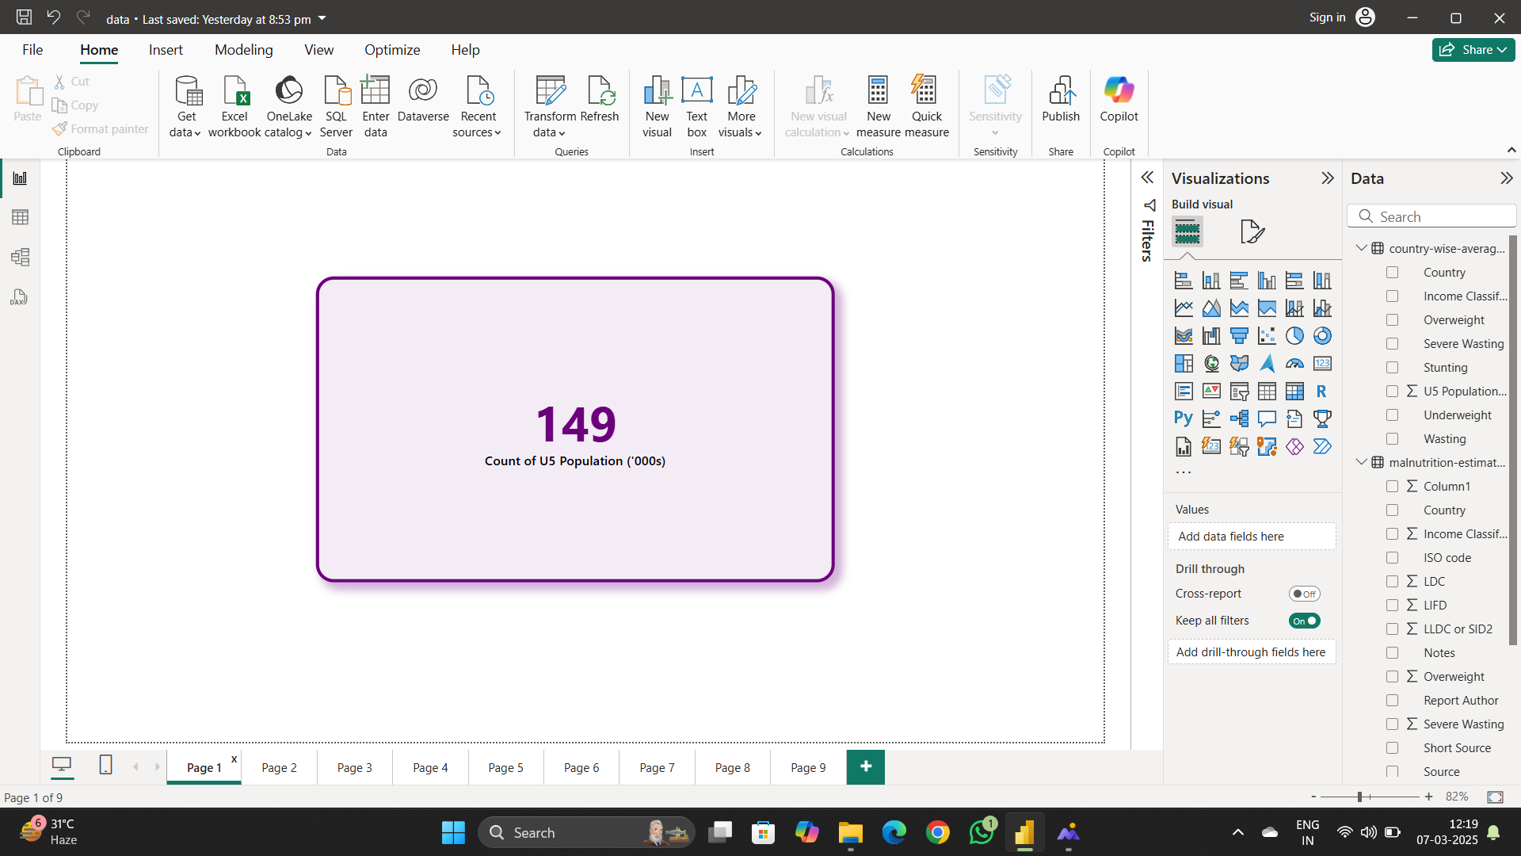

**Activity 1.2: sum of survey sample**

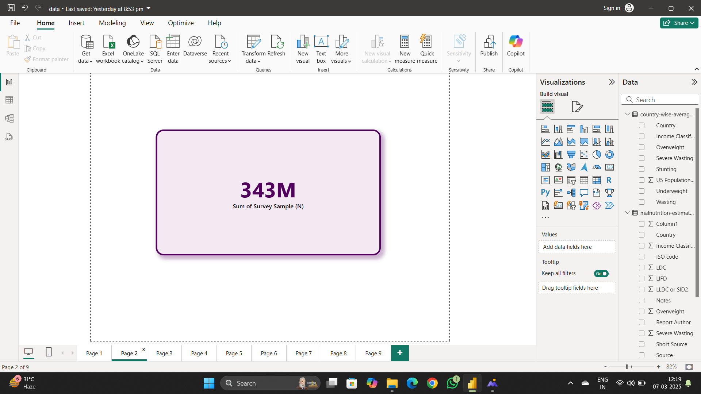

**Activity 1.3: Sum of underweight**

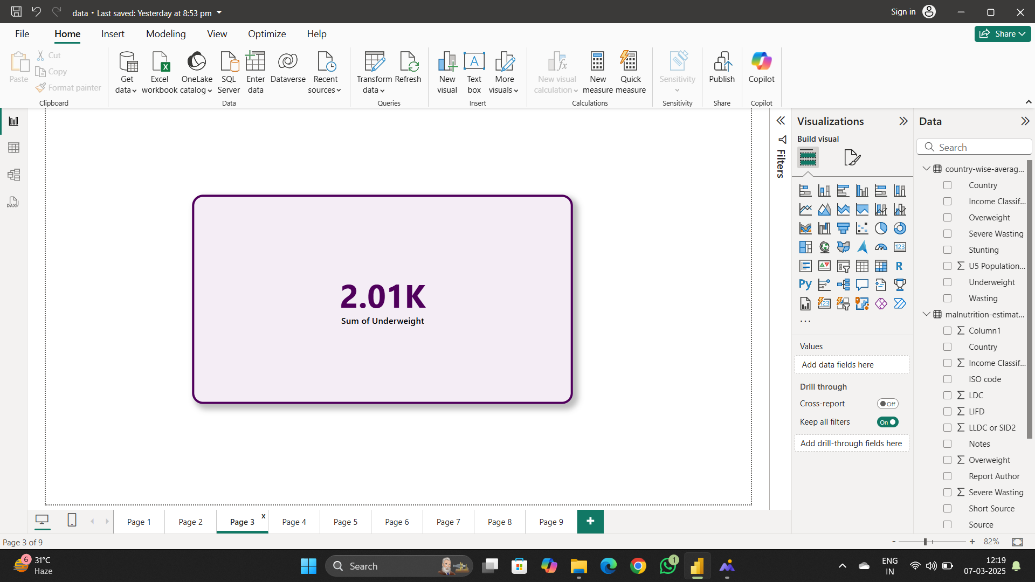

**Activity 1.4: Sum of LDC,LIFD,LLDC or SID2 and Average of Stunting by Income analysis**

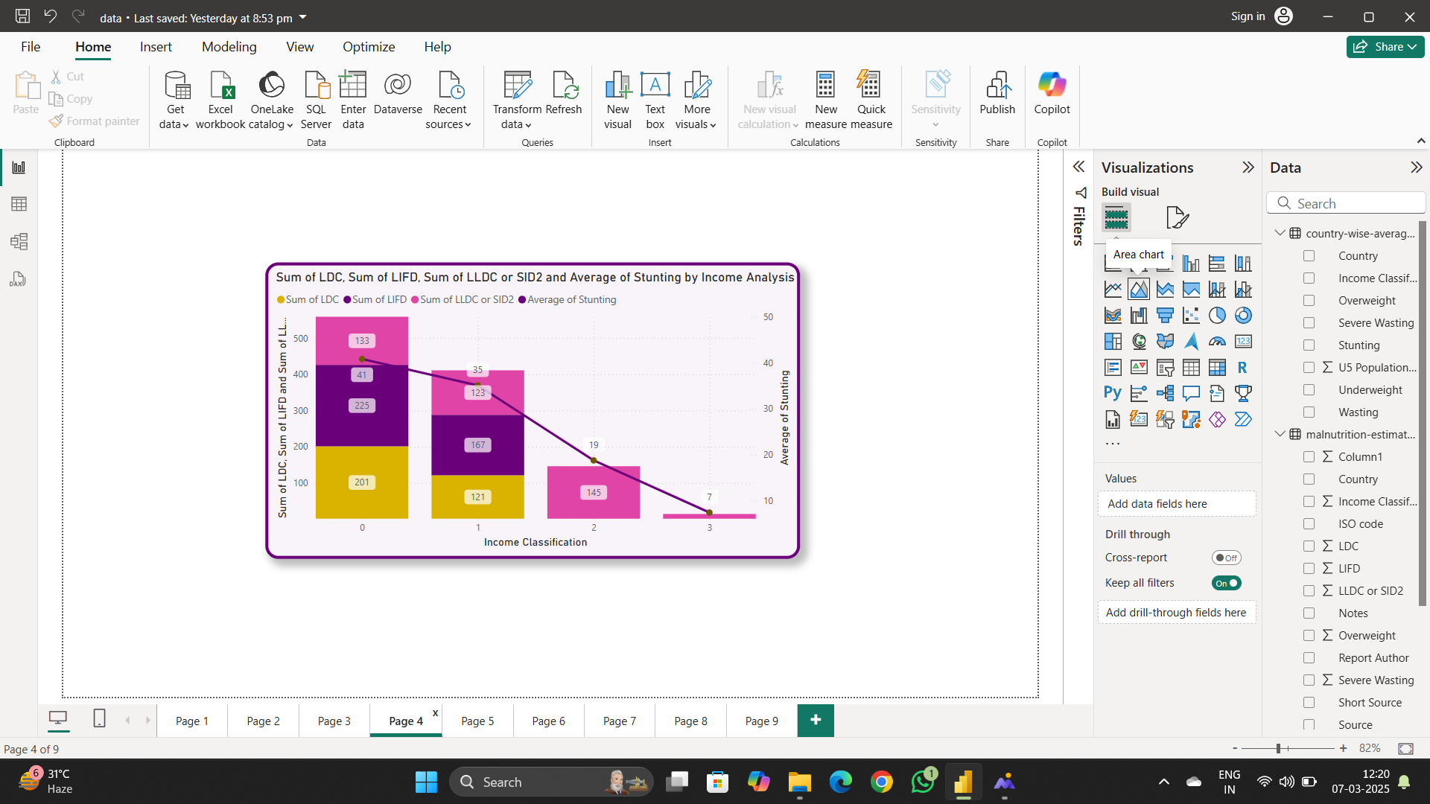

**Activity 1.5: Sum of overweight by country**

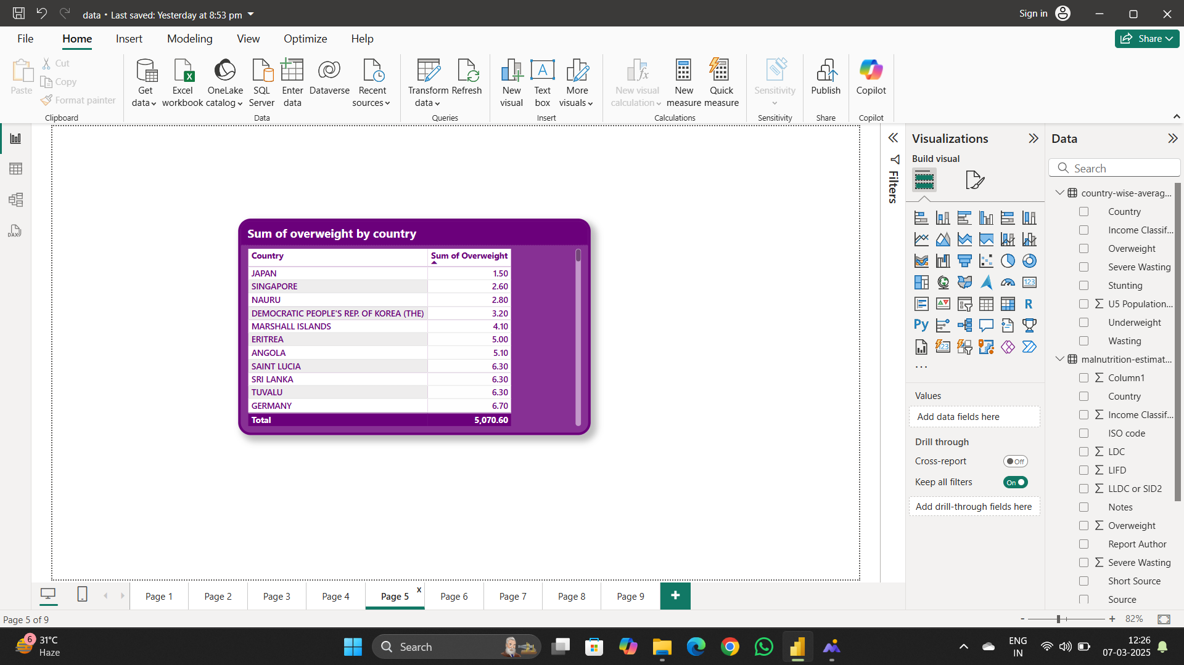

**Activity 1.6: Sum of Overweight and Underweight under Income Classification**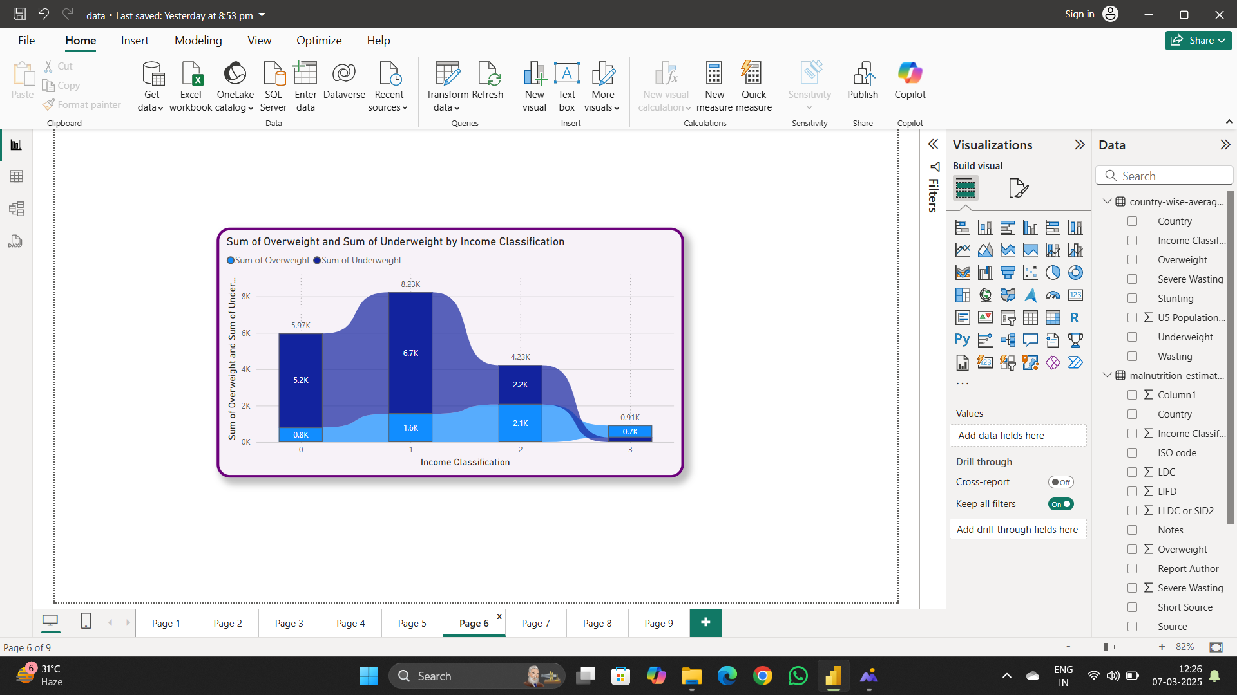

**Activity 1.7: Sum of Income Classification**

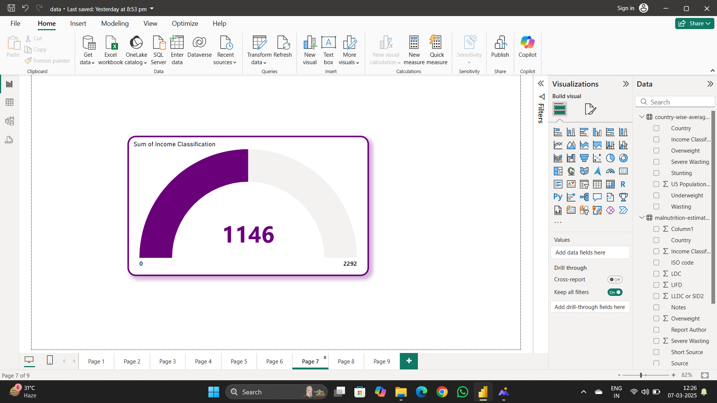

**Milestone 5: Dashboard**

A dashboard is a graphical user interface (GUI) that displays information and data in an organized, easy-to-read format. Dashboards are often used to provide real-time monitoring and analysis of data, and are typically designed for a specific purpose or use case. Dashboards can be used in a variety of settings, such as business, finance, manufacturing, healthcare, and many other industries. They can be used to track key performance indicators (KPIs), monitor performance metrics, and display data in the form of charts, graphs, and tables.

**Activity :1- Responsive and Design of Dashboard**

A dashboard is a graphical user interface (GUI) that displays information and data in an organized, easy-to-read format. Dashboards are often used to provide real-time monitoring and analysis of data and are typically designed for a specific purpose or use case.

Dashboards can be used in a variety of settings, such as business, finance, manufacturing, healthcare, and many other industries. They can be used to track key performance indicators (KPIs), monitor performance metrics, and display data in the form of charts, graphs, and tables.

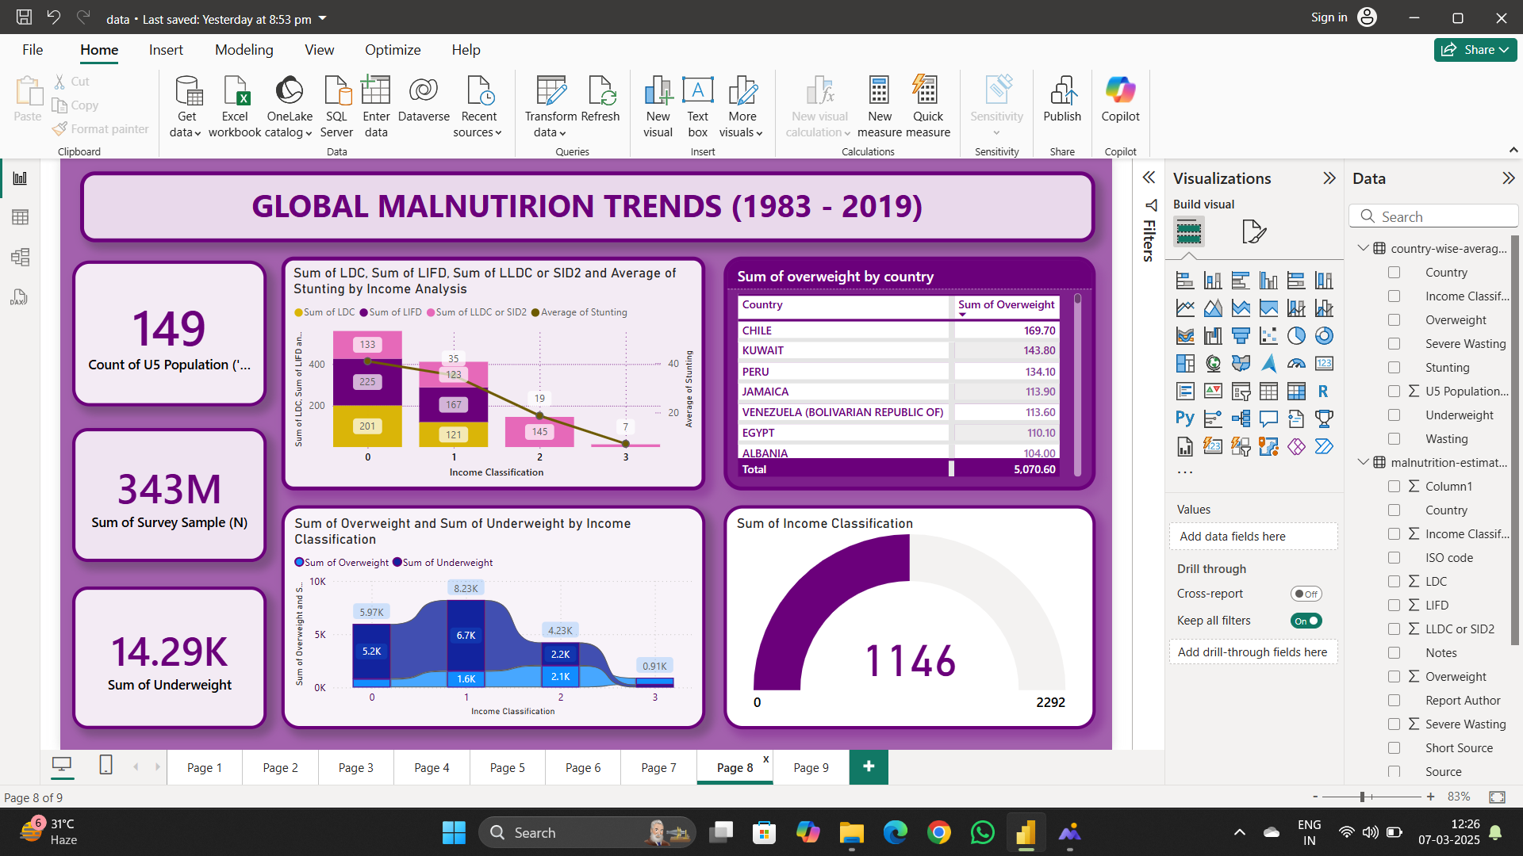

**Milestone 6: Report**

A data report is a way of presenting data and analysis in a narrative format, with the goal of making the information more engaging and easier to understand. A data story typically includes a clear introduction that sets the stage and explains the context for the data, a body that presents the data and analysis in a logical and systematic way, and a conclusion that summarizes the key findings and highlights their implications. Data Report can be told using a variety of mediums, presentations, interactive visualizations, and videos.

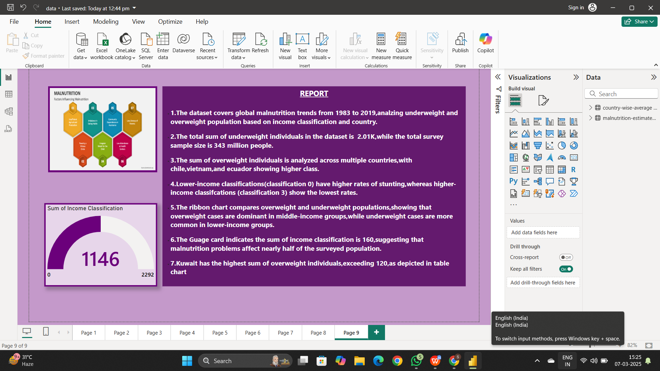

**Milestone 7: Performance Testing**

Performance testing is a crucial aspect of software development aimed at evaluating the speed, responsiveness, stability, and scalability of an application under various workload conditions. It involves simulating real-world usage scenarios to assess how the system behaves and performs under stress, peak loads, or normal conditions.

**Activity 1: Amount of Data Loaded**

"Amount of Data Loaded" refers to the quantity or volume of data that has been imported, retrieved, or loaded into a system, software application, database, or any other data storage or processing environment. It's a measure of how much data has been successfully processed and made available for analysis, manipulation, or use within the system.

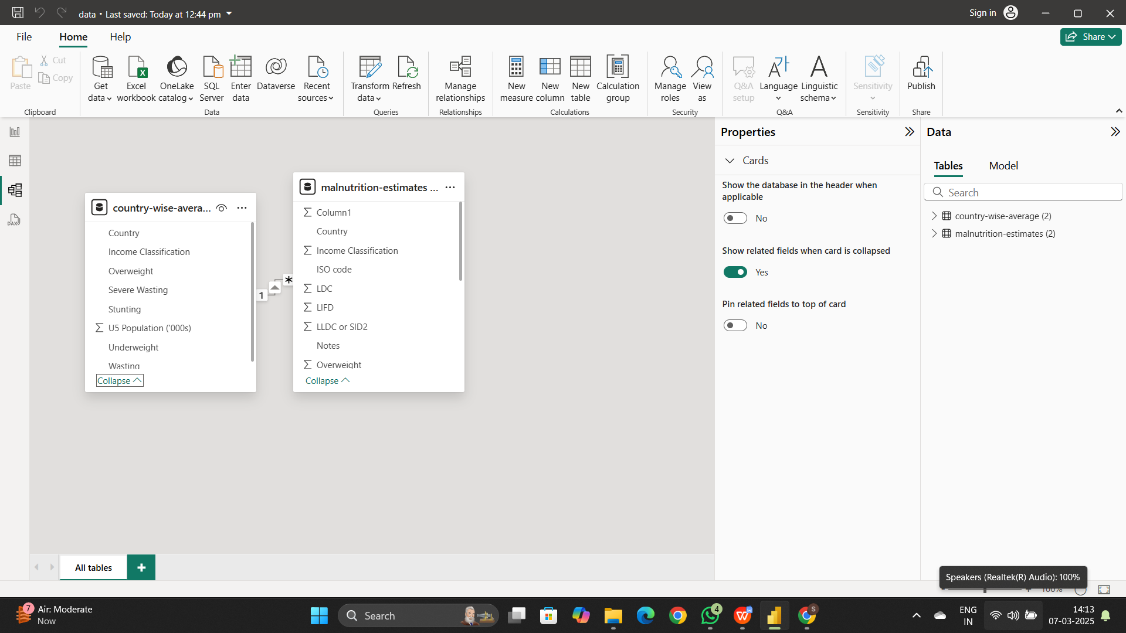

**Activity 2 : No of Visualizations/ Graphs**

* Count of U5 Population
* Sum of Survey Sample(N)
* Sum of Underweight
* Sum of Overweight by Country
* Total Income Classification
* Sum of Overweight and Underweight by Income Classification
* Sum of LDC, LIFD, LLDC or SID2 and Average of  Stunting by Income Analysis

**Activity 2.1: Utilization of Filters**

"Utilization of Filters" refers to the application or use of filters within a system, software application, or data processing pipeline to selectively extract, manipulate, or analyze data based on specified criteria or conditions.

**Selected “Country” as a Filter**

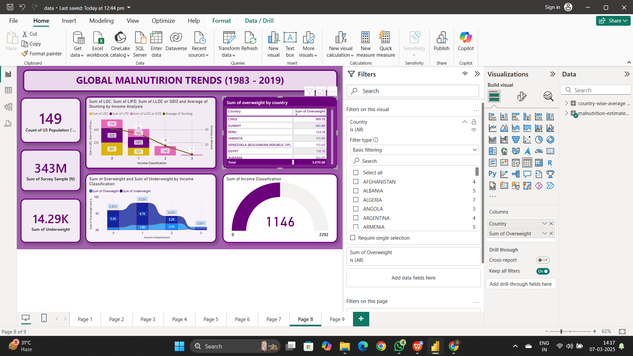

**Milestone 8: Project Demonstration & Documentation**

Below mentioned deliverables to be submitted along with other deliverables

**Activity 1:- Record explanation Video for project end to end solution**

**https://drive.google.com/file/d/17a4nLPiR76kL3tkJhD2esxPzaM7HAGqu/view?usp=sharing**

Creating a record explanation video for a project's end-to-end solution is crucial for ensuring clarity and transparency in its implementation. This video serves as a comprehensive guide, detailing every aspect of the project from inception to completion.

**Activity 2:- Project Documentation-Step by step project development procedure**